Date: Wednesday, December 6th
Time: 5:30pm – 7:00pm
Location: K.A. Brett School Cafeteria
Join us for:
-Math Games: make and take home
-Parent breakout session to talk about the math programs and how you can help your child in math.
-Pizza
-Raffles

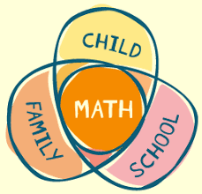
----------------------------------------------------------------------------------------------------------------------------------------------------------------
Please fill out and return to the school by December 4th.
Student Grade(s):______________________________________________
# of people attending:__________________________________________
Please comment on anything specific you would like to know about in regards to our math programs: ____________________________________________________________________________________________________________________________________________________________________________________________________

